**Name: Xingrong Zong**

1. **Service times**

|  |  |
| --- | --- |
| Name of service center | Service Time (Sk) |
| *WebServer* | **0.06** |
| *ApplicationServer* | **0.25** |
| *VoucherPaymentServer* | **0.075** |

1. **Simulation results**

|  |  |  |
| --- | --- | --- |
| Name of service center | Utilization | Throughput |
| *WebServer* | **0.1898** | **3.1533** |
| *ApplicationServer* | **0.7814** | **3.1449** |
| *Database* | **0.1107** | **3.1449** |
| *CardPaymentServer* | **0.3510** | **1.7599** |
| *VoucherPaymentServer* | **0.0565** | **0.7521** |

|  |
| --- |
| 3.8914 |

Average System Response Time:

|  |
| --- |
| 0.5499 |

Average time that a user is waiting for a reply from the system

1. **System upgrade**

|  |  |  |  |
| --- | --- | --- | --- |
| Name of service center | Minimum number of resources | Utilization | Throughput |
| *WebServer* | **2** | **0.8599** | **14.2869** |
| *ApplicationServer* | **7** | **1** | **3.9453** |
| *Database* | **1** | **0.1393** | **4.0053** |
| *CardPaymentServer* | **3** | **0.4508** | **2.2368** |
| *VoucherPaymentServer* | **1** | **0.0725** | **0.9605** |

|  |
| --- |
| 3.96E5 |

Average System Response Time:

|  |
| --- |
| 0.547 |

Average time that a user is waiting for a reply from the system

# a)

## Web Server

## Application Server

## Database

## User Thinking

## Voucher Payment Server

# b)

## Model

### Source 1

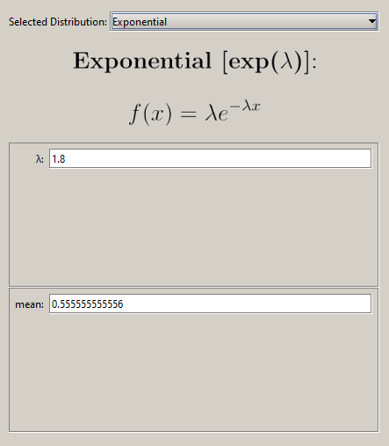

### Web Server

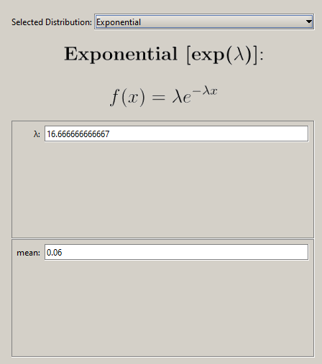

### Application Server

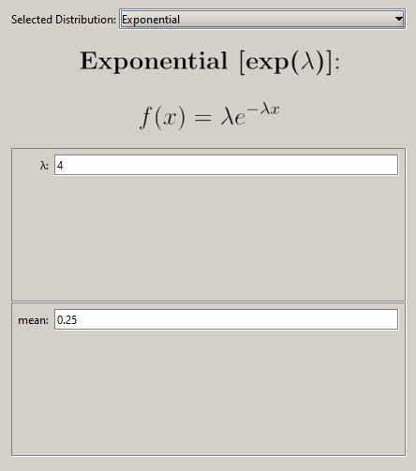

### Database

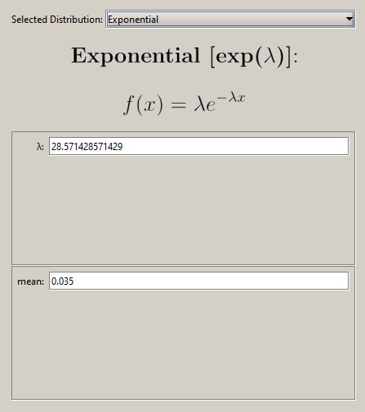

### CardPayment Server

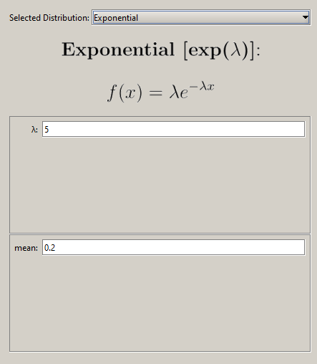

### VoucherPayment Server

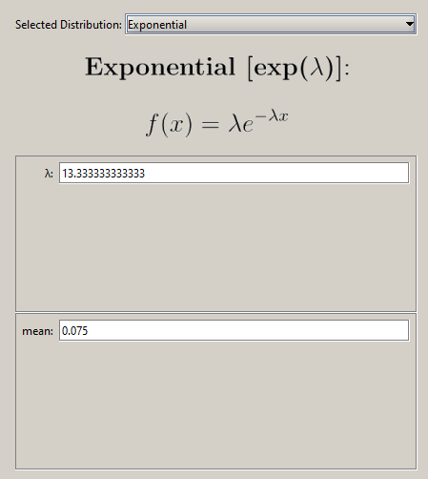

## Routing Probabilities

### Database

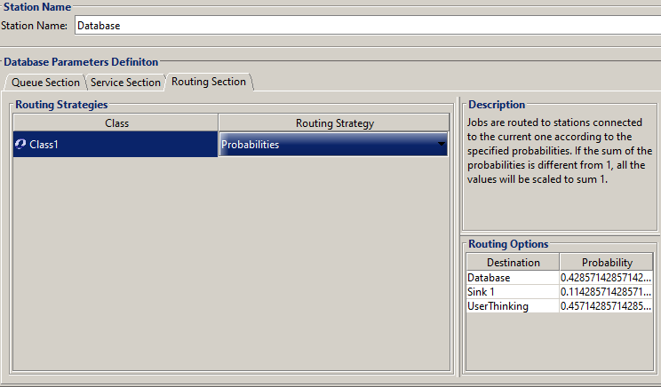

### User Thinking

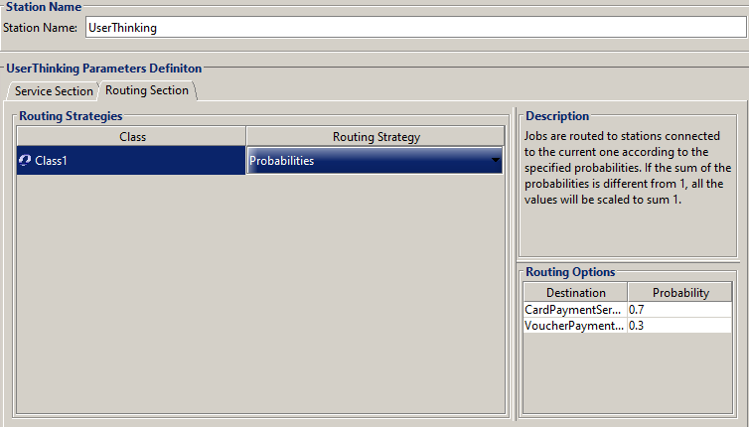

### CardPayment Server

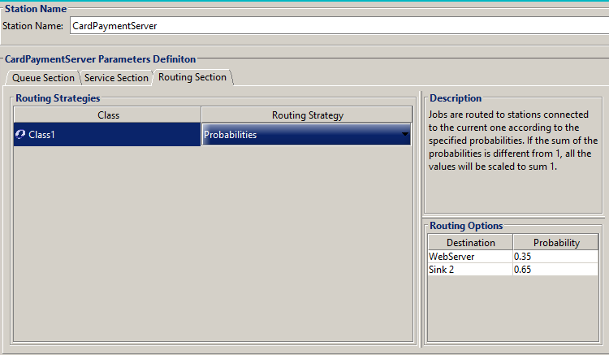

### VoucherPayment Server

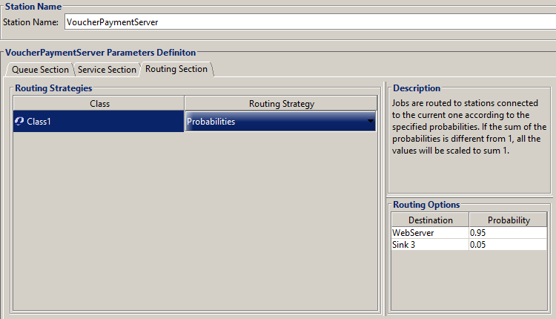

## Simulations

### System Number of Customers

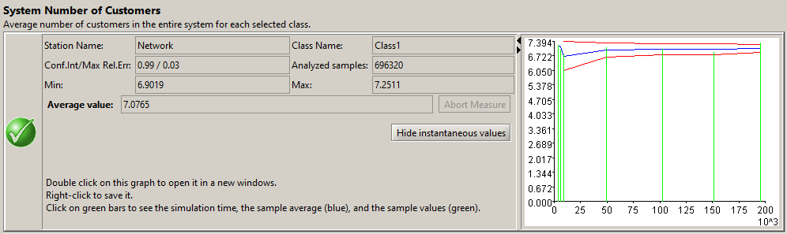

### System Response Time

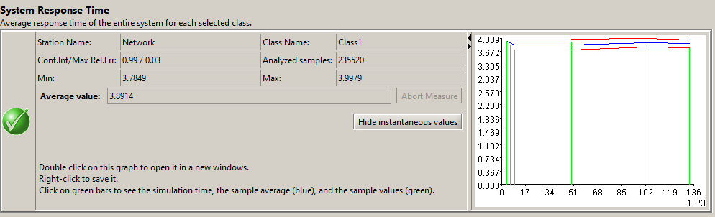

### System Throughput

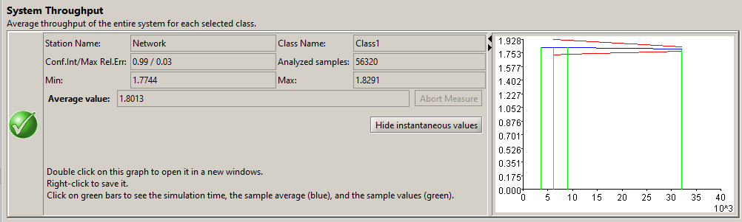

### Residence Time

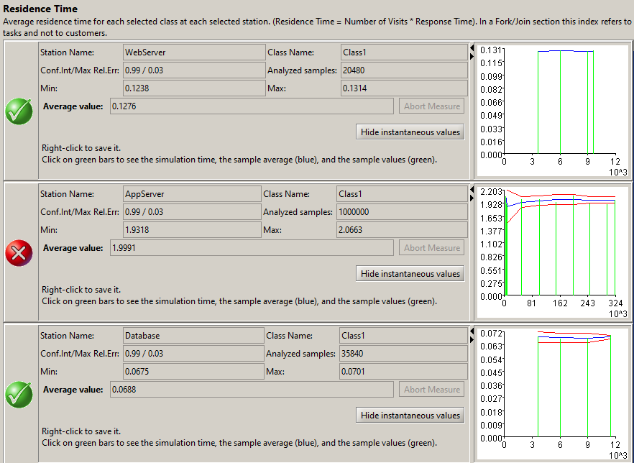

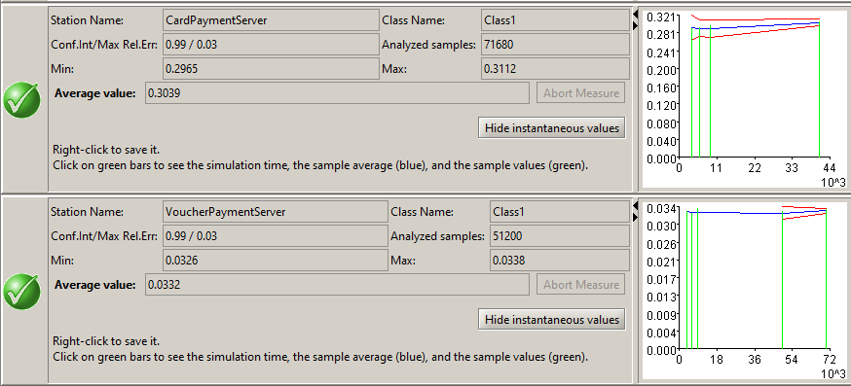

### Utilization

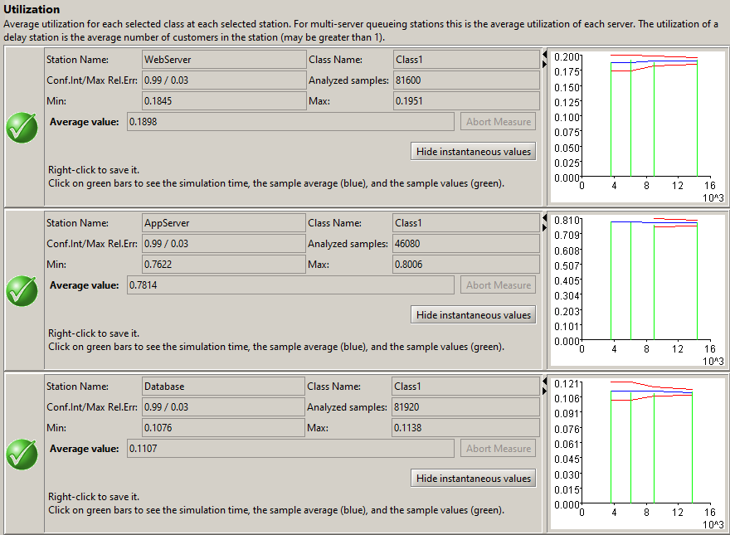 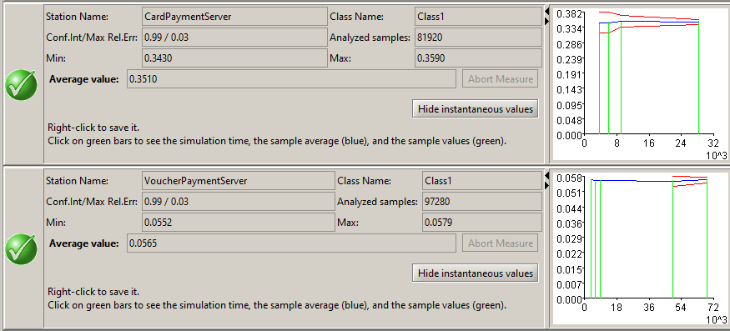

### Throughput

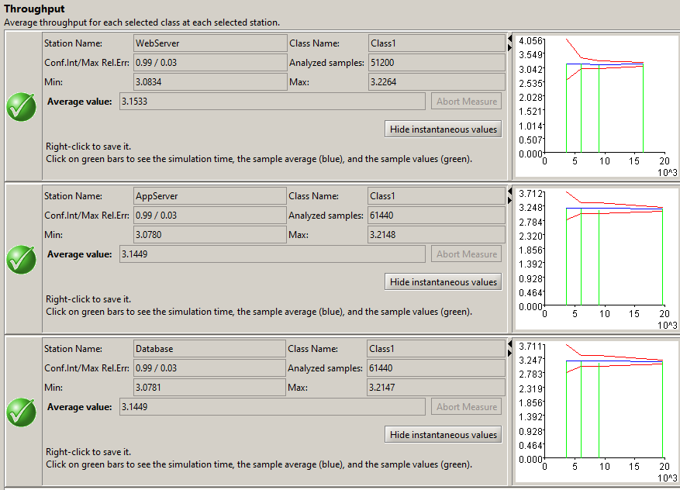 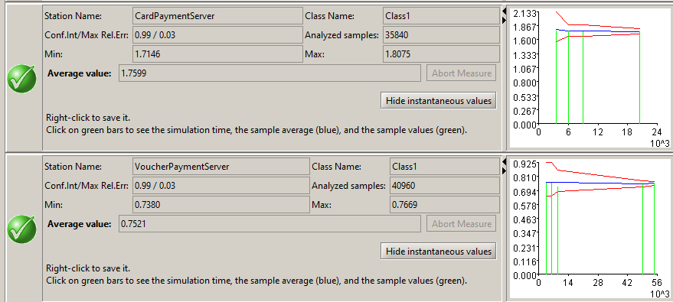

### Response Time

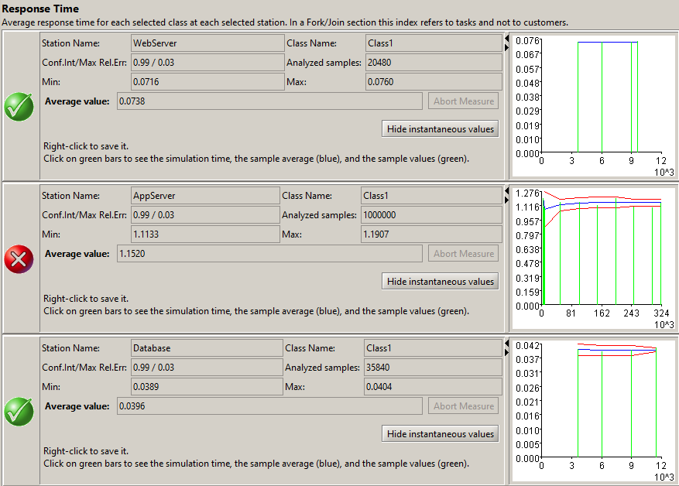 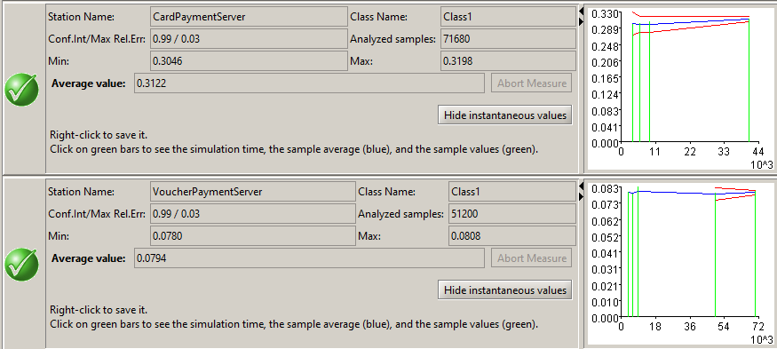

# C)

The following only shows the ones that are adjusted based on part b).

## Model

### Source 1

## 

## Routing Probabilities

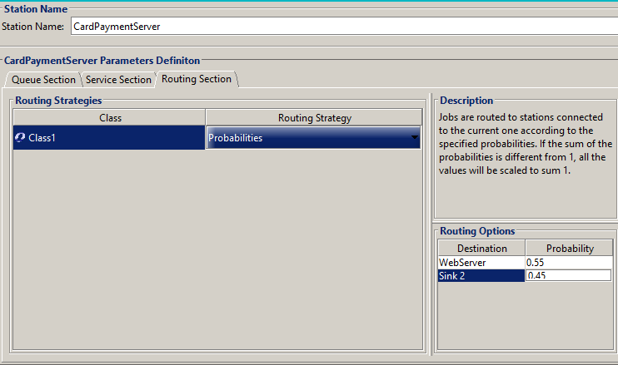

## Simulations

### System Number of Customers

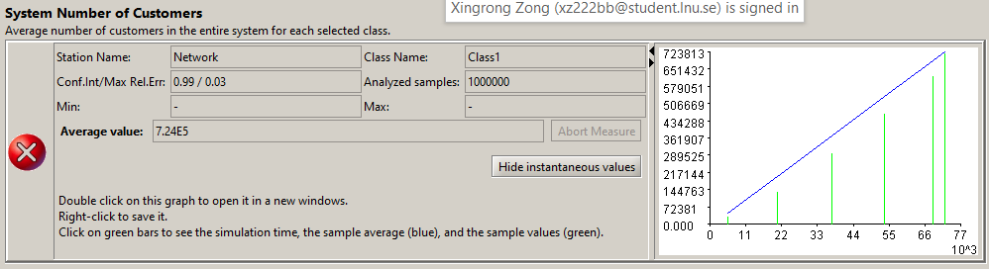

### System Response Time

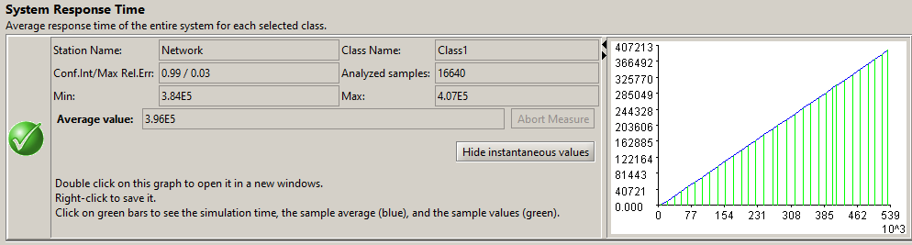

### System Throughput

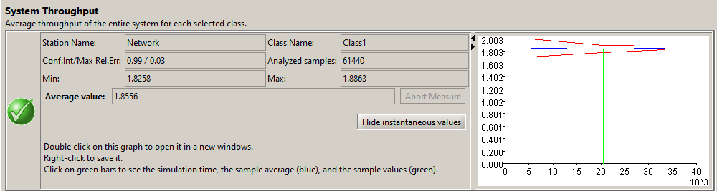

### Residence Time

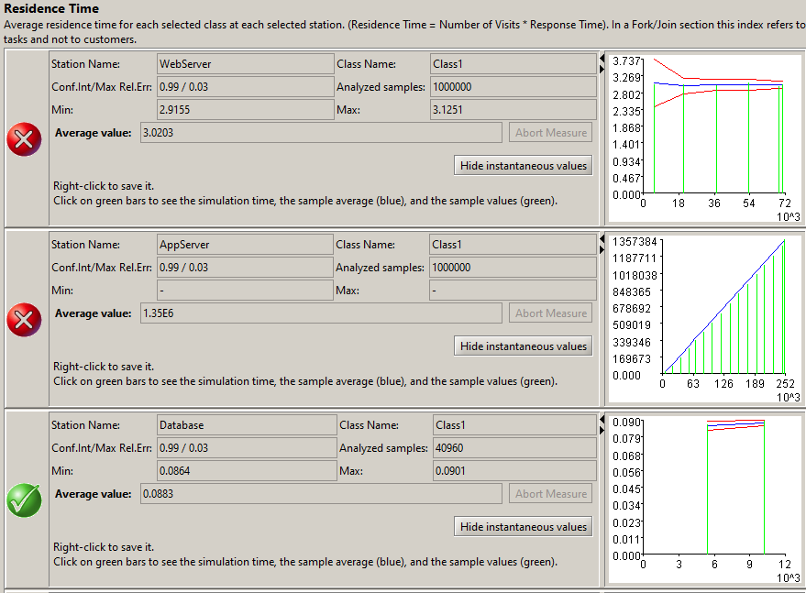

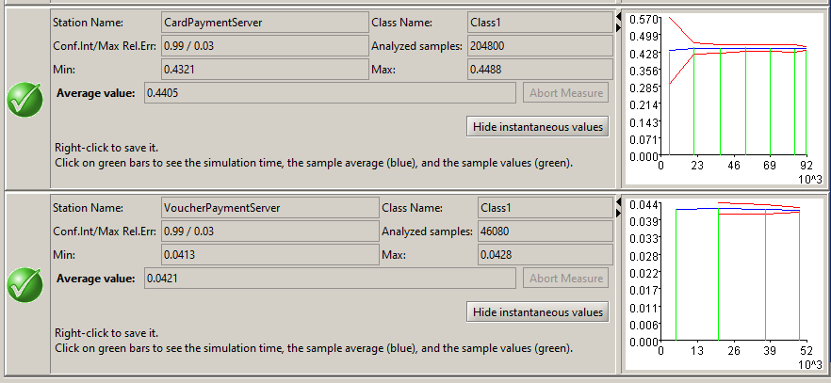

### Utilization

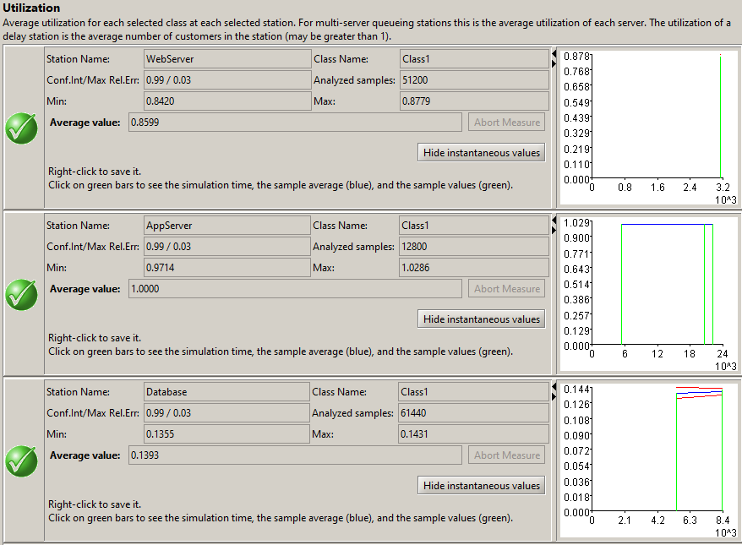

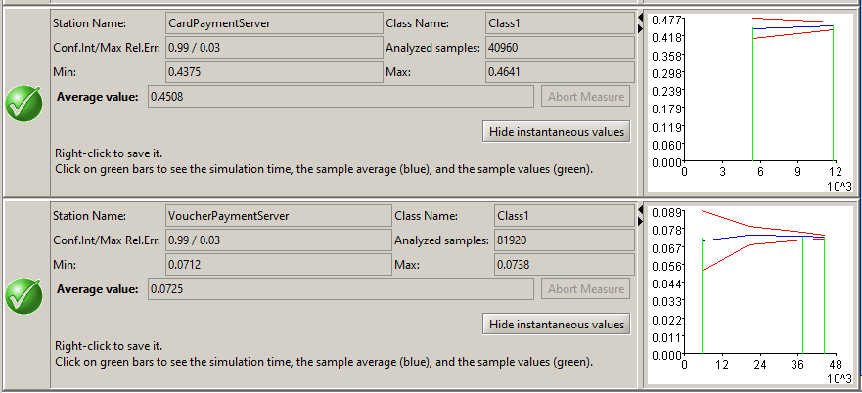

### Throughput

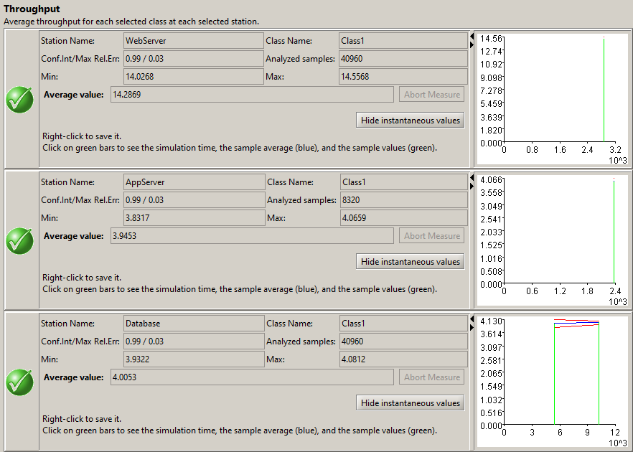 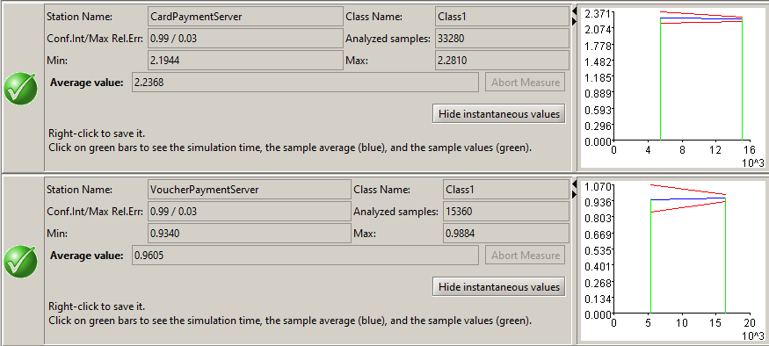

## Minimum Number of Resources

When Number of Resources of AppServer is 7, Number of Resources of Web Server is 2, Number of Resources of CardPayment Server is 3, Number of Resources of the rest servers is 1:

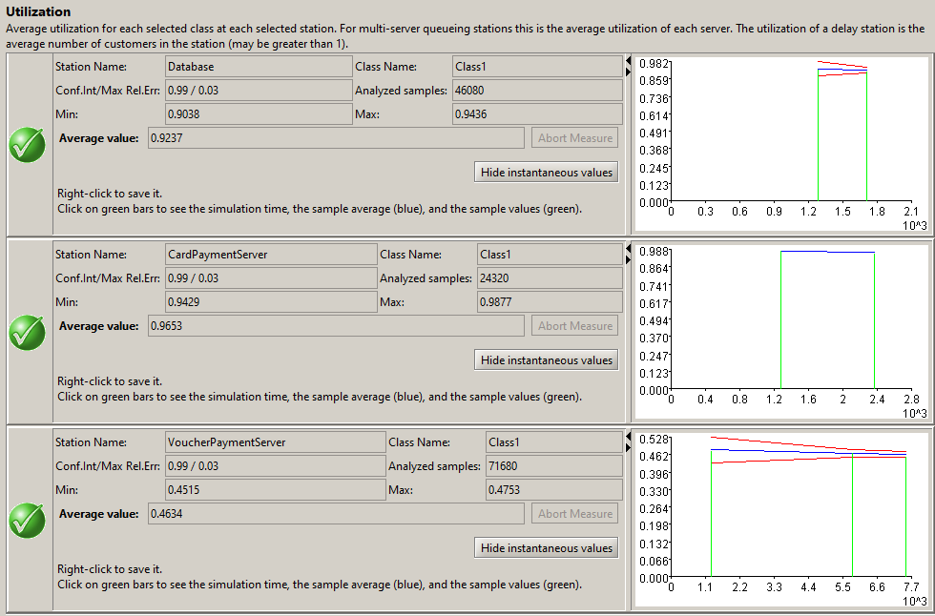

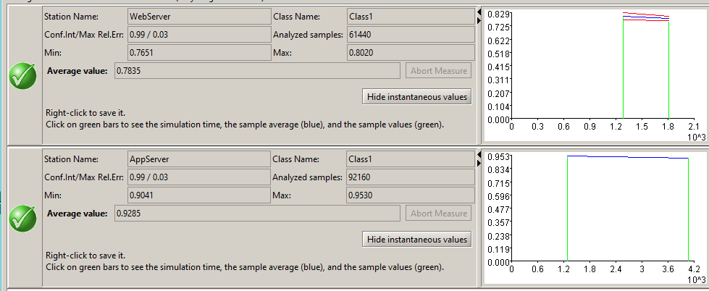

The following are the steps:

### Application Server

Number of Resources = 4:

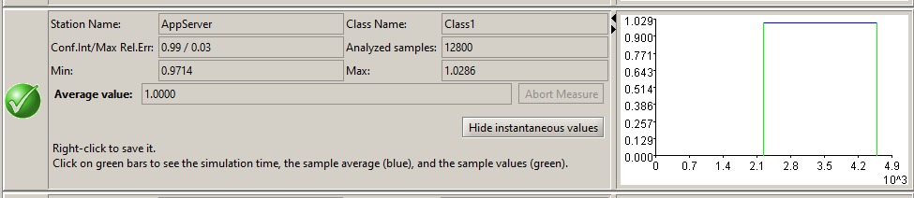

Number of Resources = 5:

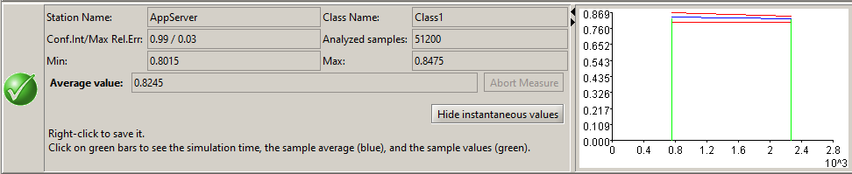

### Web Server

When Number of Resources of AppServer is 5:

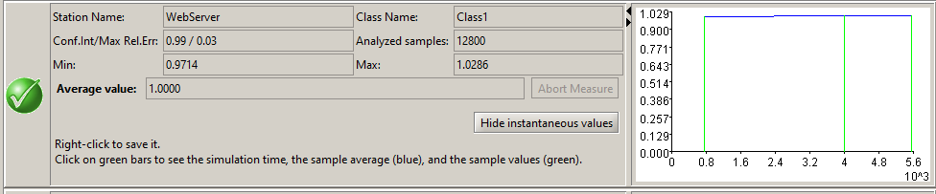

Therefore increases Number of Resources to 2:

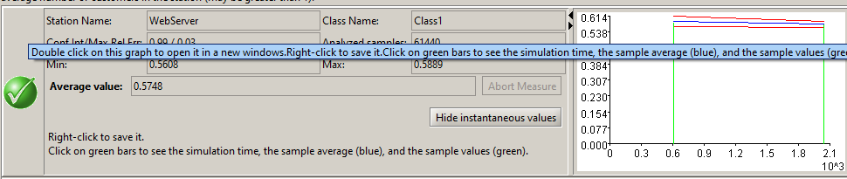

### CardPayment Server

When Number of Resources of AppServer is 5, Number of Resources of Web Server is 2:

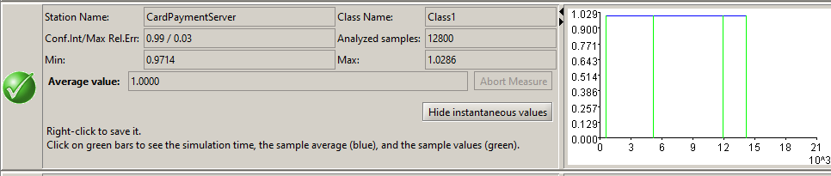

Therefore increases Number of Resources to 3:

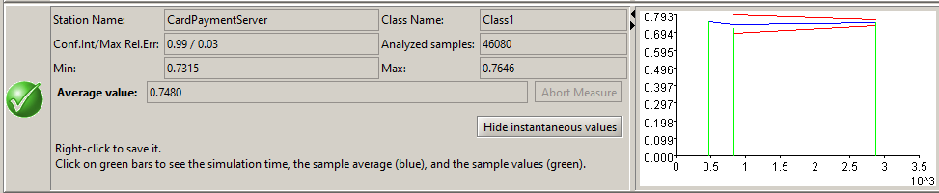

### Application Server

When Number of Resources of AppServer is 5, Number of Resources of Web Server is 2, Number of Resources of CardPayment Server is 3:

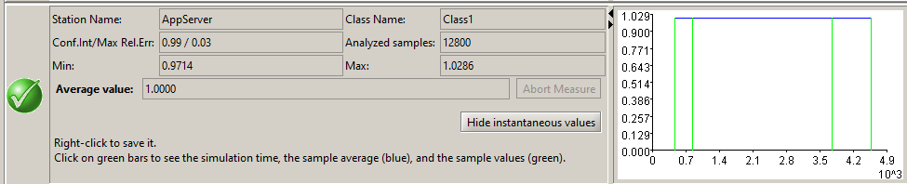

Therefore increases Number of Resources to 7:

